**Jira Installation and configuration guide**

|  |  |  |  |
| --- | --- | --- | --- |
| **Document Name** | **Version** | **Prepared by** | **Reviewed by** |
| Jira Installation and configuration guide | v.01 | Tarunendra Tripathi | Sumit Malhotra |
|  |  |  |  |

Contents

Introduction 1

Get the file to install 1

Configure Port 2

Option for Complete installation 2

Enable Firewall 3

Jira on browser 3

Update license Key 4

Create/Update Admin Account 4

UAT Urls 5

Setup Jira Project 6

# Introduction

This document contains the installation and configuration of Jira on RHEL environment.

# Get the file to install

Download below mentioned file for installation.

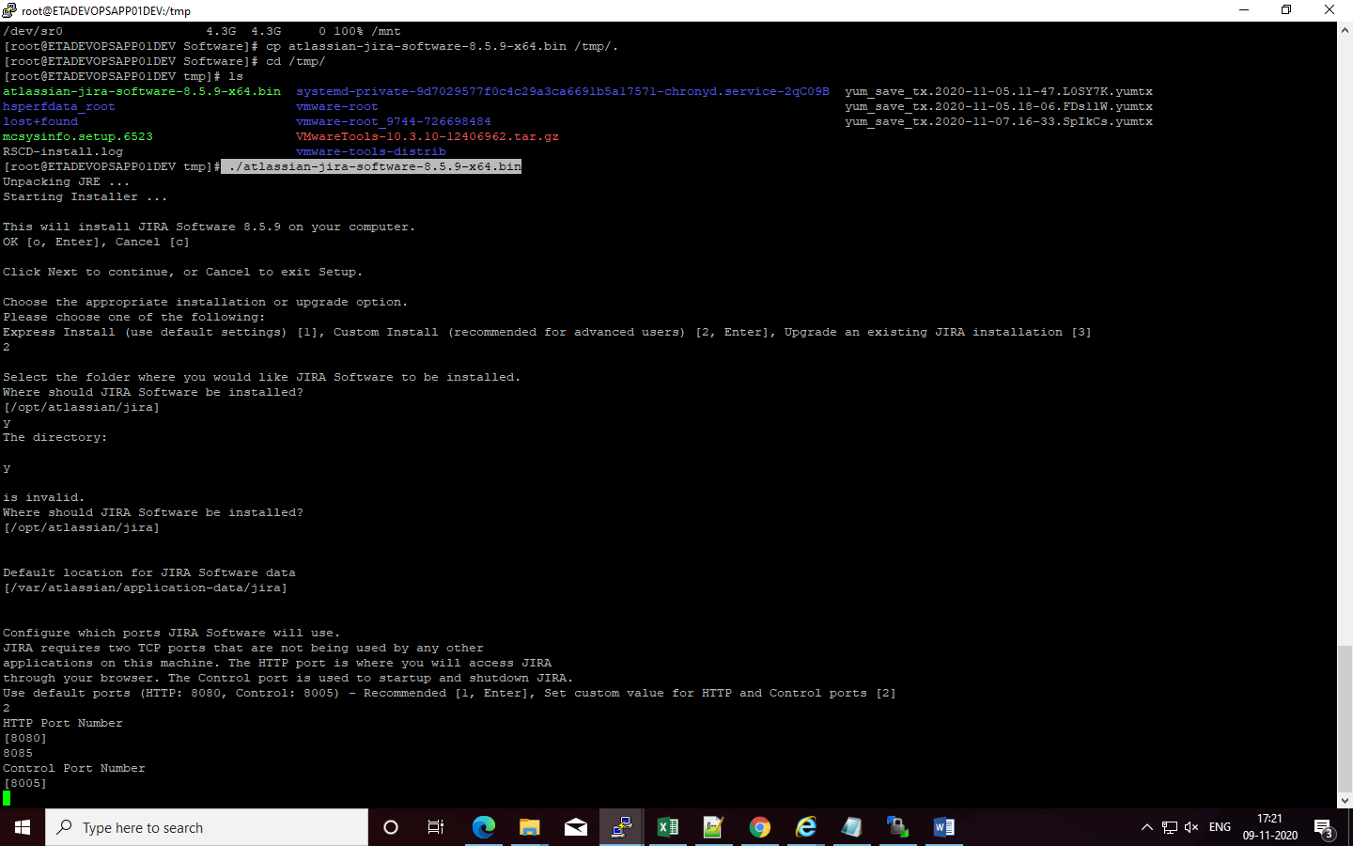

# Configure Port

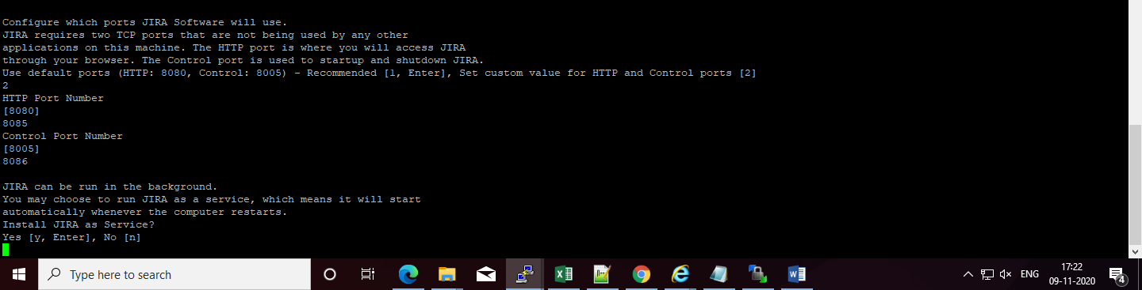

# Option for Complete installation

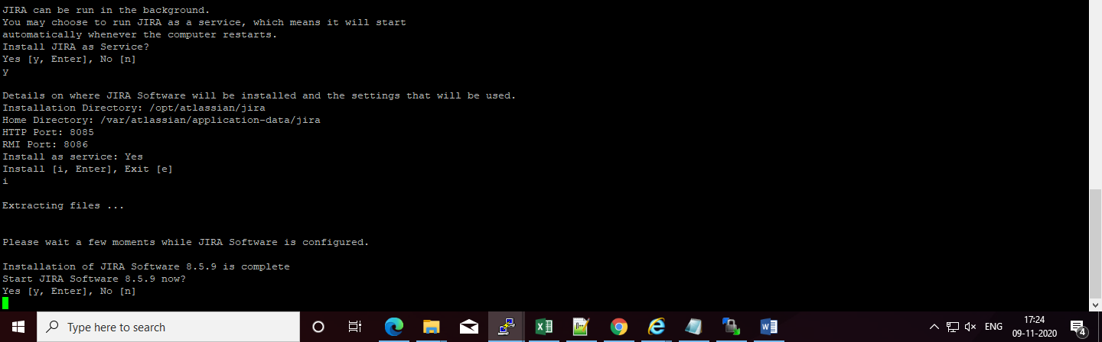

# Enable Firewall

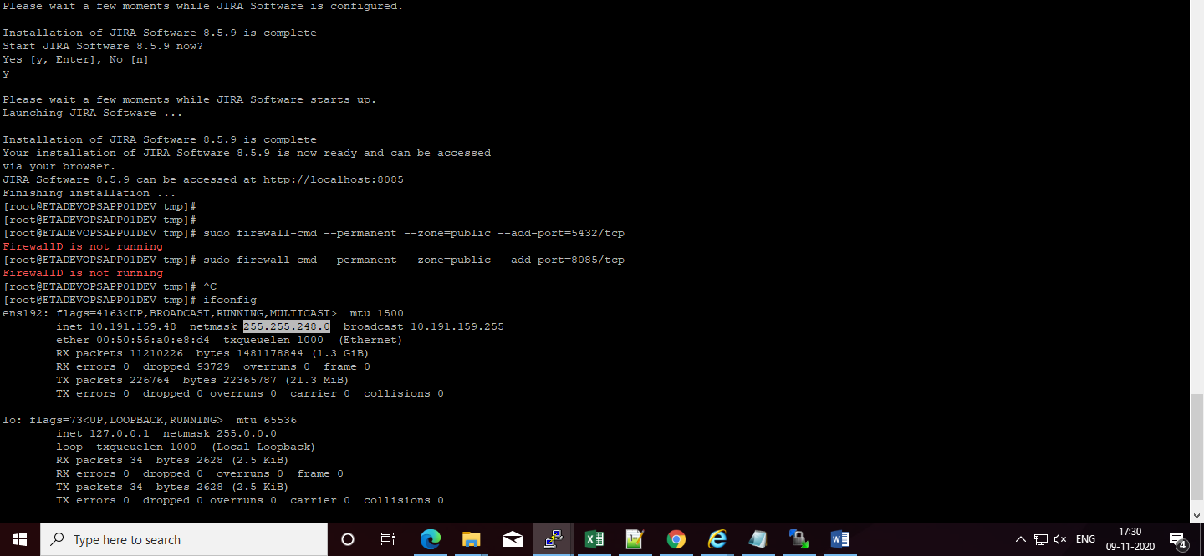

# Jira on browser

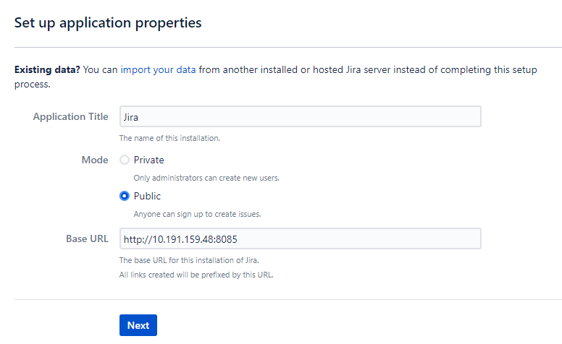

# Update license Key

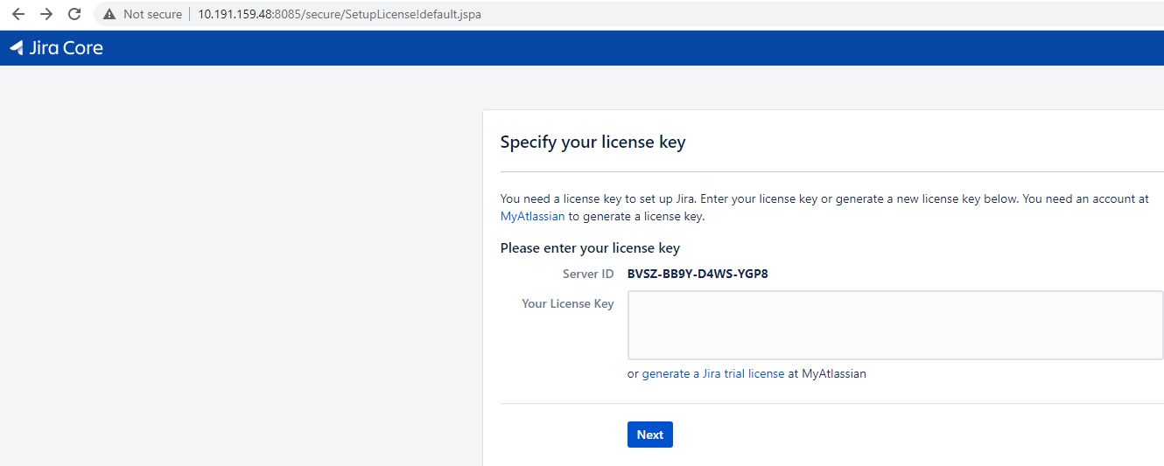

# Create/Update Admin Account

Password for TarunendraTripathi user is -- password

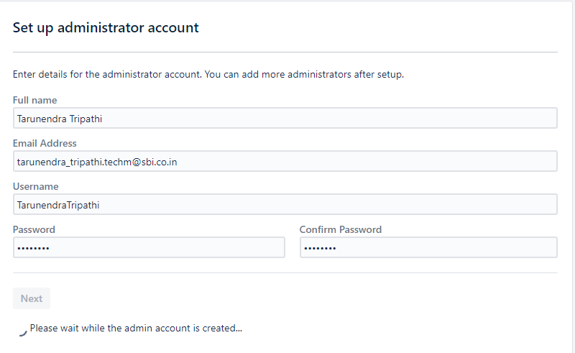

# UAT Urls

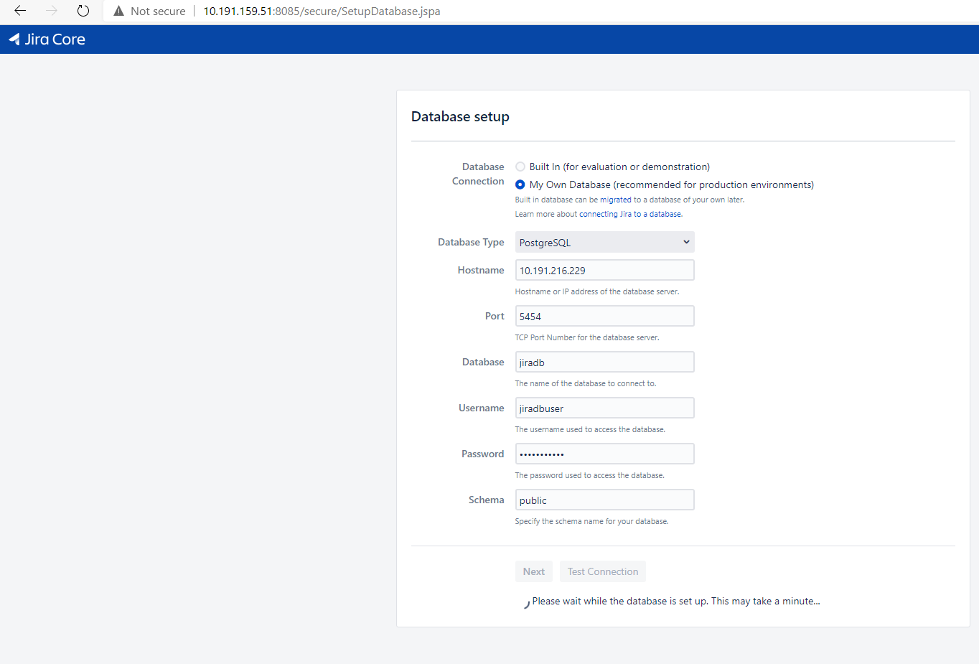

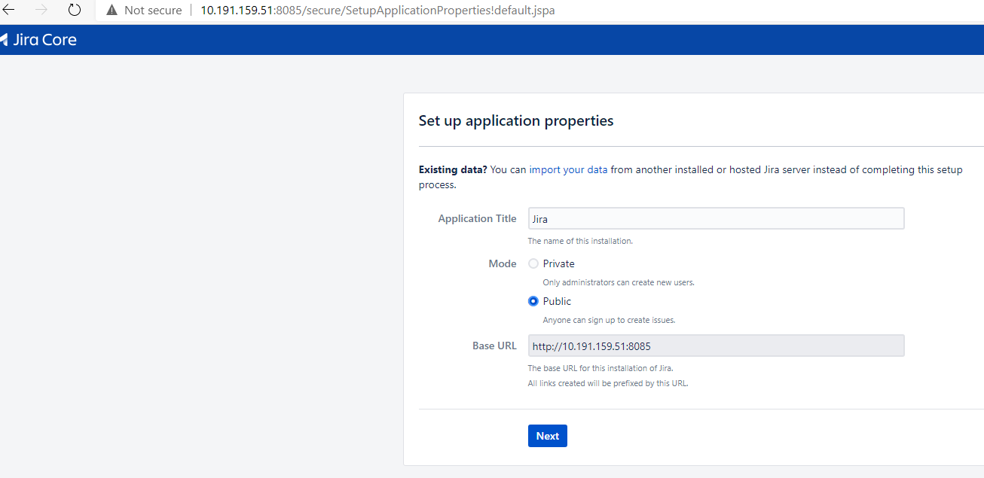

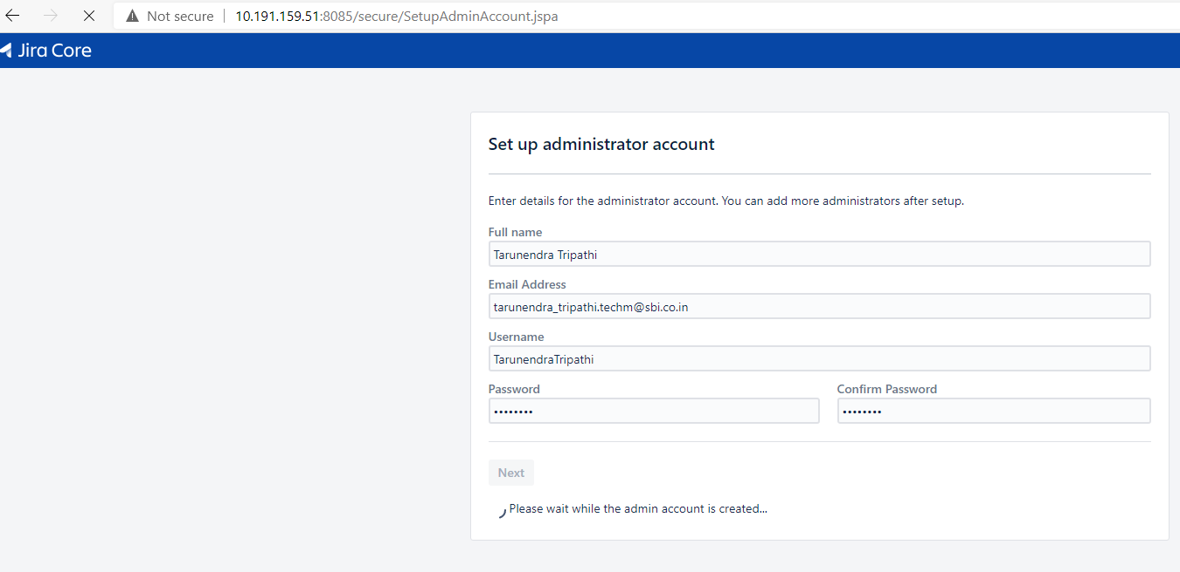

# Setup Jira Project

